Renew Fortinet Update File on the USB Stick

- Please locate the Fortinet router (Example of a Fortinet router)
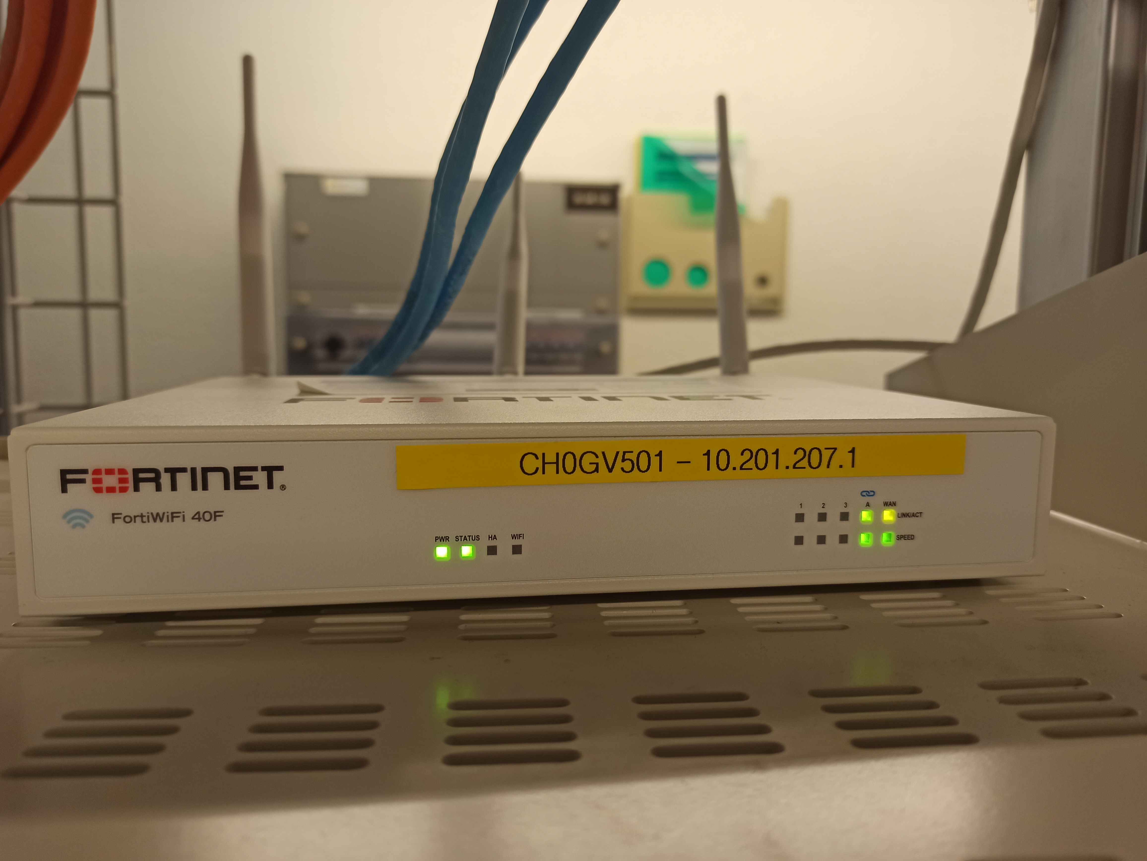

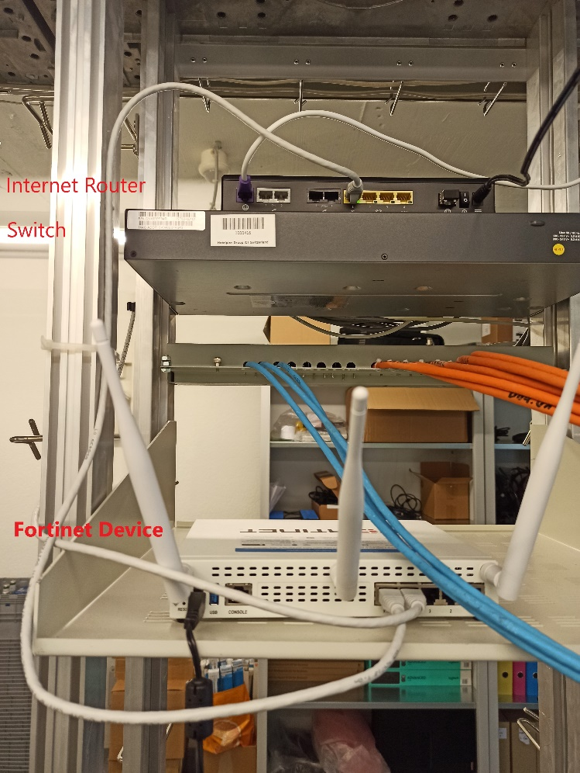
- On the back of the router, you see the power cable to the left and some network cables connected.

- Next to the power cable, you find a USB stick. Please remove it from the router and plug it in a computer.
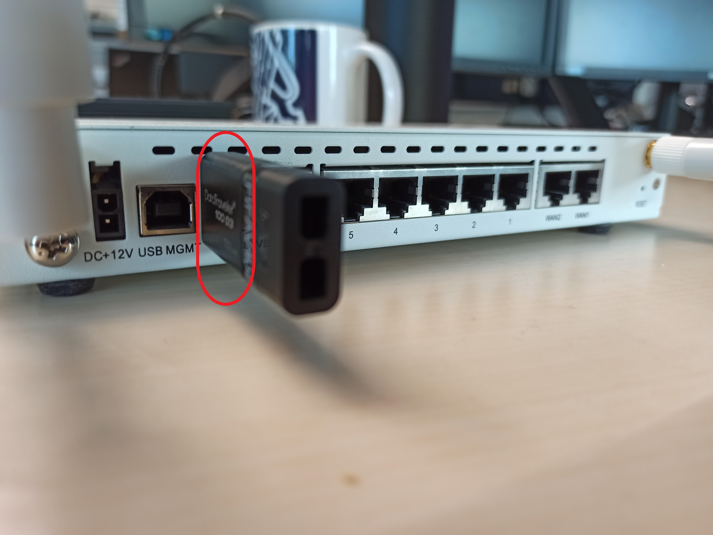
- If there is no USB stick, please organize one (it does not require more than 8GB) and continue with the following steps. Please also get in touch with Pedro Prol Martinez (pedro.prolmartinez@hotelplan.com) and report the device.

- Plug the USB stick in a computer (Please don't use IGEL devices, they're not powerful enough to handle the download). Now it should appear a new storage device.
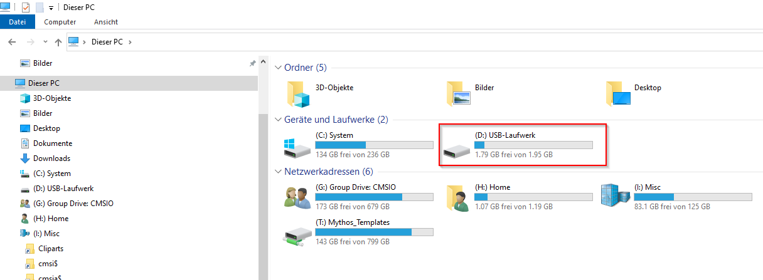
- Go to https://webaccess.hotelplan.com/HTTPDownload/Downloads/Forti40F/ and download the file 'FWF_40F-v6.M-build2000-FORTINET.out.exe' or use directly this link: https://webaccess.hotelplan.com/HTTPDownload/Downloads/Forti40F/FWF_40F-v6.M-build2000-FORTINET.out.exe

- After downloading, rename the file (right click on the file and select 'Rename'). Remove the '.exe' part and save it as 'FWF_40F-v6.M-build2000-FORTINET.out'. There will pop up a warning message, saying that the file might not be useable anymore. Please confirm by clicking on 'Yes'
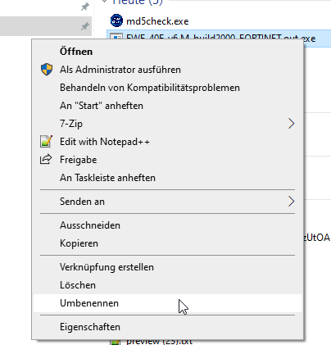
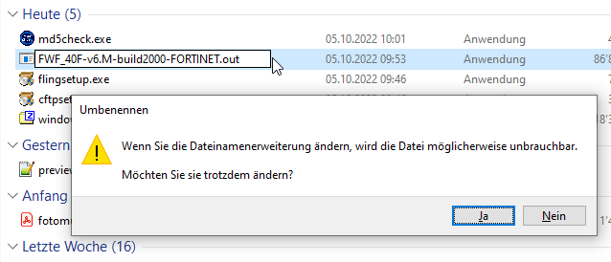

- Copy the downloaded and renamed file to the USB stick. As result, the content should look like on the picture.
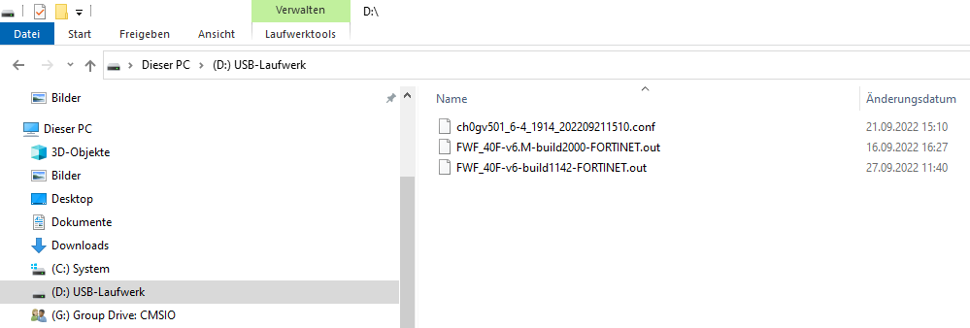

- Remove the USB stick safely from your computer.
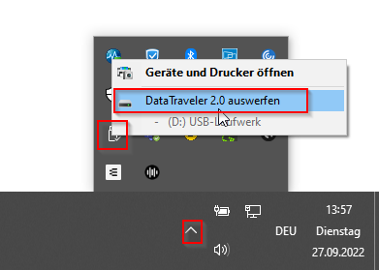

- If there was no USB stick in your Fortinet router, please stop here and wait until you get contacted from a Hotelplan colleague with further instructions. Otherwise continue.

- Plug it back in to the Fortinet router.
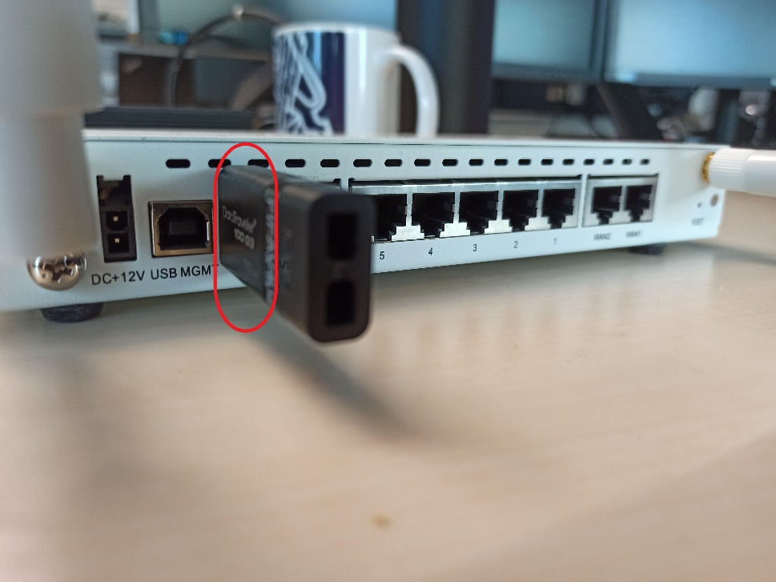

- Please confirm the update by completing the Google form here: https://forms.gle/7fn8FEQt6ZKQV3N46

